Hidden Terminal Problem

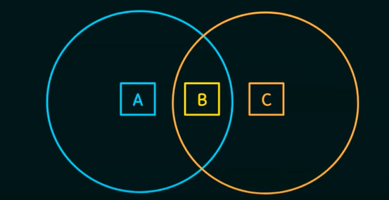

1. Suppose both A and C wants to communicate with B and so they each send it a frame.
   1. A and C are unaware of each other since their signals do not carry that far.
   2. These two frames collide with each other of B (But unlike Ethernet, neither A nor C is aware of this collision)
   3. A and C are said to be hidden nodes with respect to each other

Solution:

Multiple Access Collision Avoidance (MACA) Algorithm – RTS and CTS (Will be detailed in the later lectures)